U1L8/FILM/Flynn Sophia B.
An Inconvenient Truth: Notes Organizer
Student Sample 1
OBJECTIVE: THS Scholars will track fact and impression/image in order to analyze their influence on a documentary film’s storytelling.
INSTRUCTIONS: As you view the documentary An Inconvenient Truth, make notes on Facts/Information that resonate with you and on the Images that accompany the factual information (Columns 1 and 2). After we have viewed the entire film, you will go back and analyze the effect each combination of Information and Image has on the documentary’s storytelling (Column 3). You will need at least six examples from the film. Boxes will expand as you type.
BACKGROUND: An Inconvenient Truth is an issue-based documentary that aims to raise awareness about global warming and makes the compelling case that global warming (now known more commonly as Climate Change) is real, man-made, and will have cataclysmic effects if we don’t act now. Director Davis Guggenheim weaves the science of global warming with former Vice President Al Gore’s personal history and lifelong commitment to reversing the effects of global climate change in this 2006 documentary that is widely credited with changing public perception worldwide on this issue.
KEY CONTRIBUTORS: Director: Davis Guggenheim, Writer: Al Gore, Cinematographers: Robert Richman, Davis Guggenheim

COLUMN 1 COLUMN 2 COLUMN 3
(During Viewing) (During Viewing) (After Viewing)
Information that Resonates with Me | Image that Accompanies This Information | Analysis of How This Combination of Information and Image Advances Storytelling
Al Gore’s professor was the first person to measure the carbon dioxide of the Earth’s and he did this through weather balloon in the Pacific. His professor saw the changes within our society and made connections and projects based on the pattern. This was a moment of inspiration for Gore. | The graph that was discussed is shown, which depicts a rise in carbon dioxide levels in the Earth’s atmosphere. There are two graphs shown: a more modern one and the original graphs from the professor’s experiment. Images of the professor that conducted this experiment and Gore in college are also illustrated in this scene. | The idea that carbon dioxide is rising is amplified in the film’s storytelling by using the visual image of the graph and the personal narrative of being exposed to the information being a moment of inspiration for Gore. The viewer can understand exactly the image Gore is describing in this scene and well see a window into Gore’s college life through the images shown, increasing the viewer’s connection with him. Additionally, the graph allows the viewer to visual and understand the basic idea of rising carbon dioxide levels.
Ice cores can tell us the story of how much carbon dioxide was in the atmosphere at a certain point in time | While Gore explains how ice cores work, the process of using them is depicted. | The image of ice core being observed and used helps the viewer put an image to the phenomenon Gore is explaining, which helps to make to make it seem more concrete as they see the physical aspect of the more abstract and complicated idea he is explaining.
The population was 2.3 billion in 1945, 6.4 billion in 2005, and is projected to be 9.1 billion in 2050. We are putting increased pressure on the Earth’s vulnerable resources as this population rises. | Gore shows a graph of population and also shows the difference between the Haiti and Dominican Republic to depict the effects of human pressure on the environment. | The graph of the rising population serves to accentuate the juxtaposition between the low population for most of human history and the boom in the past 50 years. Also, an image of an aerial view of Haiti and the Dominican Republic, shows how human behavior can wreak havoc on the environment as Haiti put significantly more pressure on the land, which is clear in the image. This image, in addition to the graph of population emphasize to the viewer the negative consequences on the Earth if the population continues to rise exponentially and human behavior remains the same, to underscore how our collective behavior must change.
The United States is responsible for a disproportionate amount of carbon dioxide and is significantly they greatest carbon dioxide contributor. | Gore shows a bar graph of carbon dioxide emission | The bar graph of carbon dioxide emphasizes Gore’s point about the United States being the greatest carbon dioxide contributor because the viewer can easily comprehend that difference between the carbon dioxide emission of the US compared to other countries and regions. This furthers the film’s storytelling because the viewer better understands that climate change is not an issue that the United States is separate from, but in fact directly influence, which highlights to the viewer a need to take action.
Carbon Dioxide is at record high heights and the number is much higher above the natural cycle; this will continue to go up | Gore extends the graph of historic CO2 level to predicted summers and he rises on the later as the camera pans up. | The image of the graph continuing to rise along with Gore and the camera physically moving emphasizes to the viewer the predicted exponential rise in carbon dioxide emission and thus the importance that they take action to reduce carbon emissions

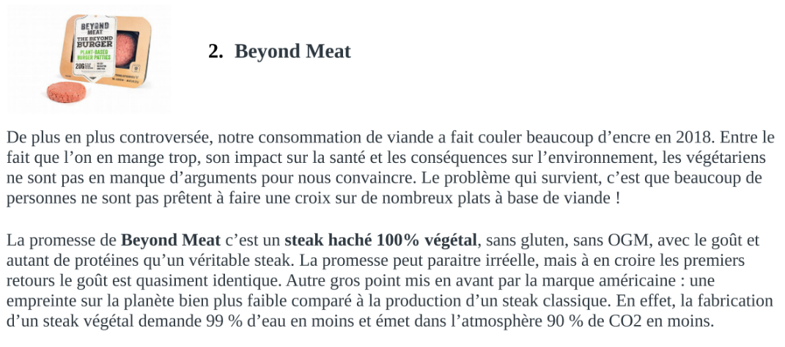
Student Sample 2

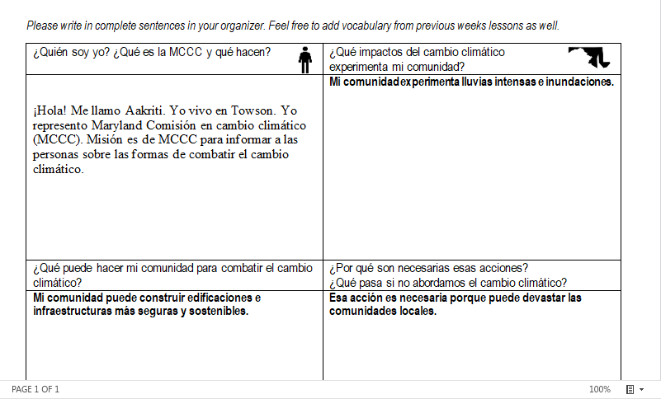
Student Sample 3


Student Sample 4

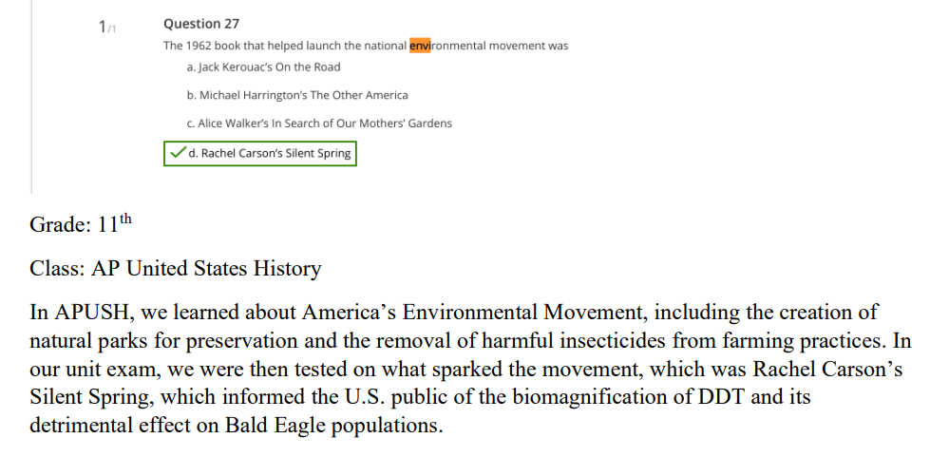
Student Sample 5
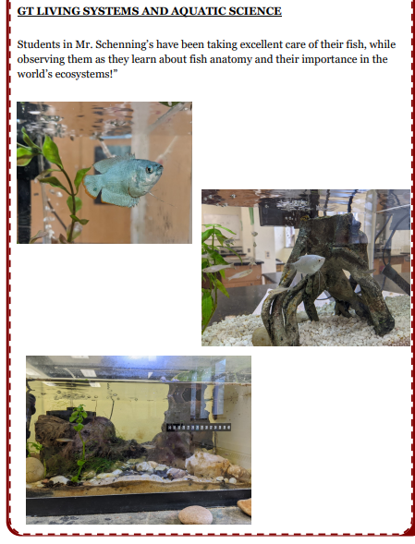
Student Sample 6

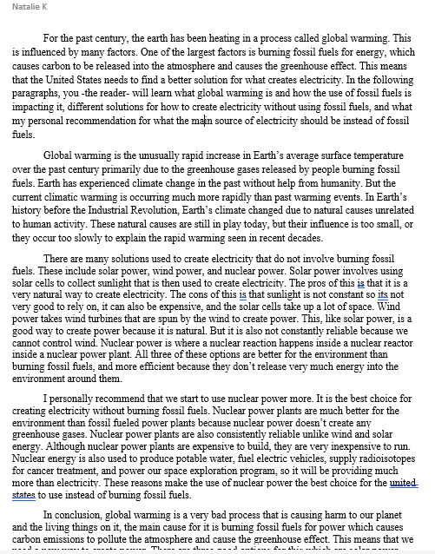
Student Sample 7
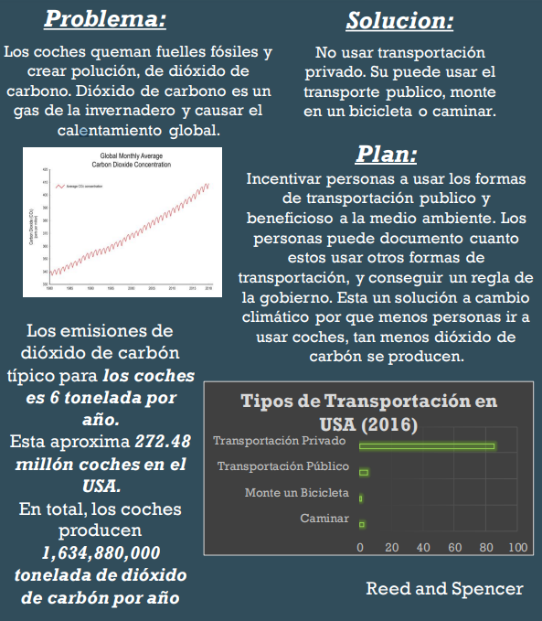
Student Sample 8

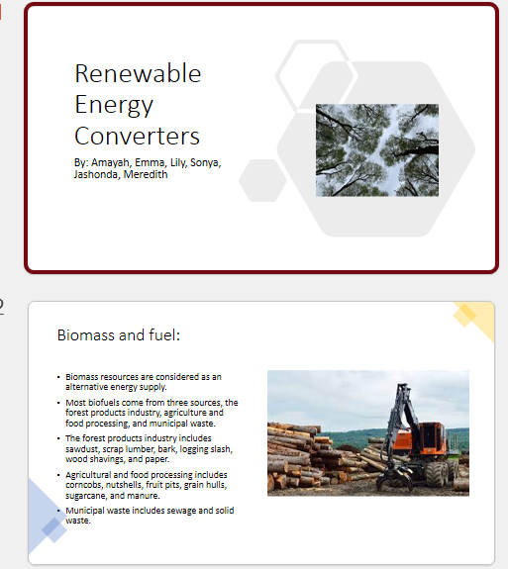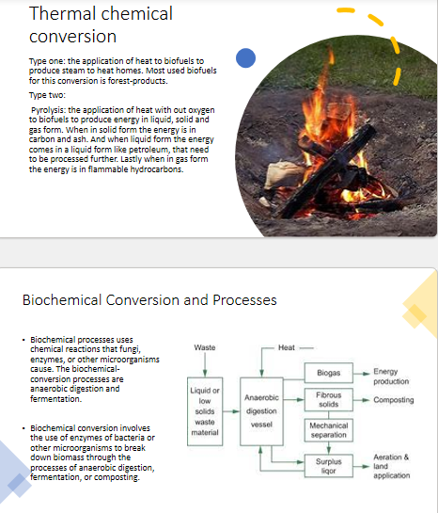

Student Sample 9

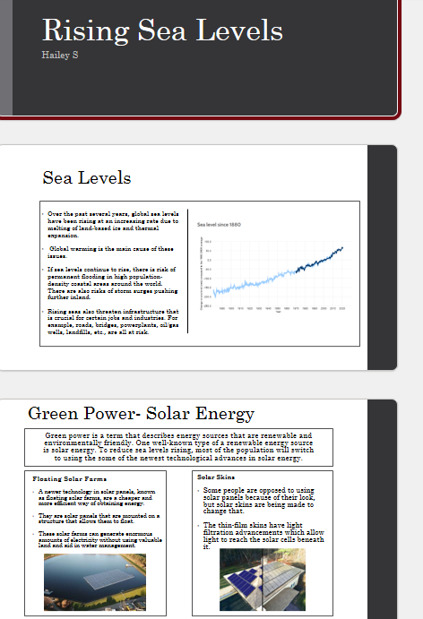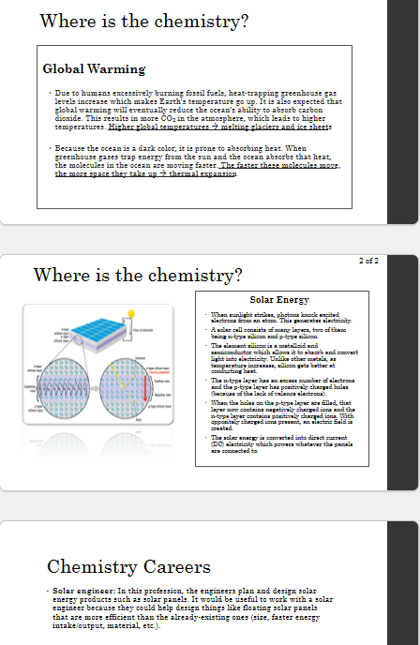
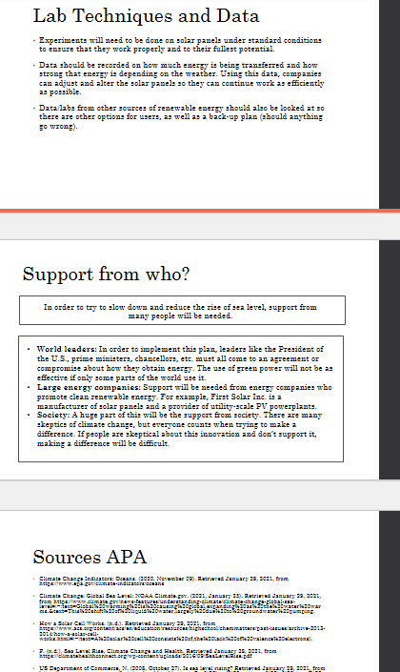
Student Sample 10

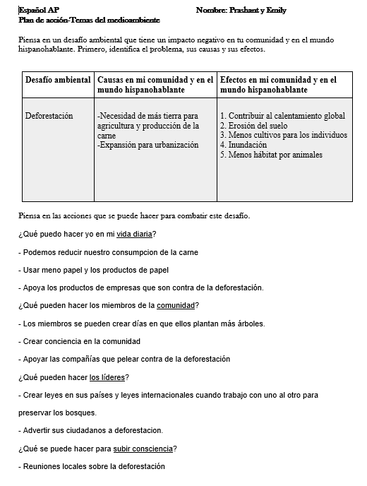
Student Sample 11

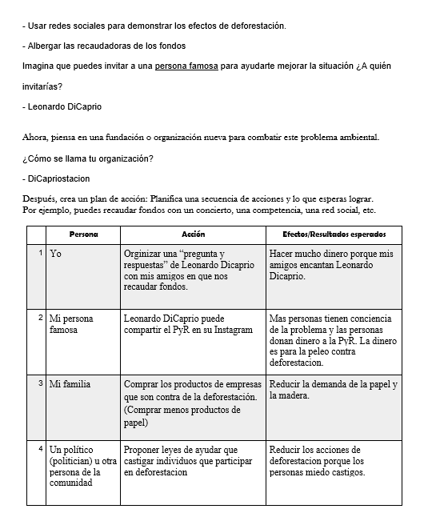


Student Sample 12

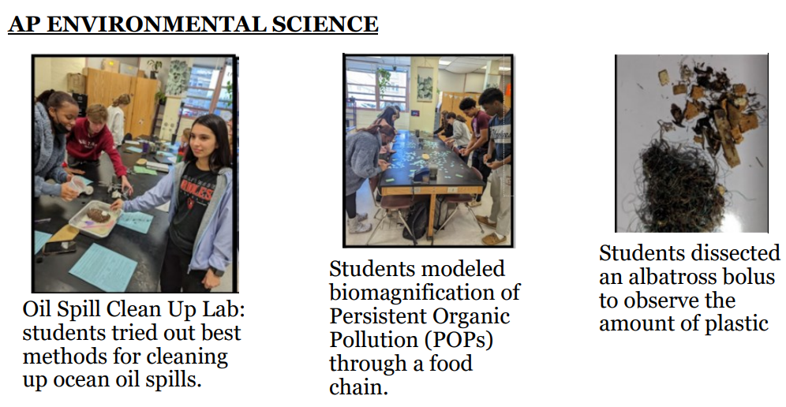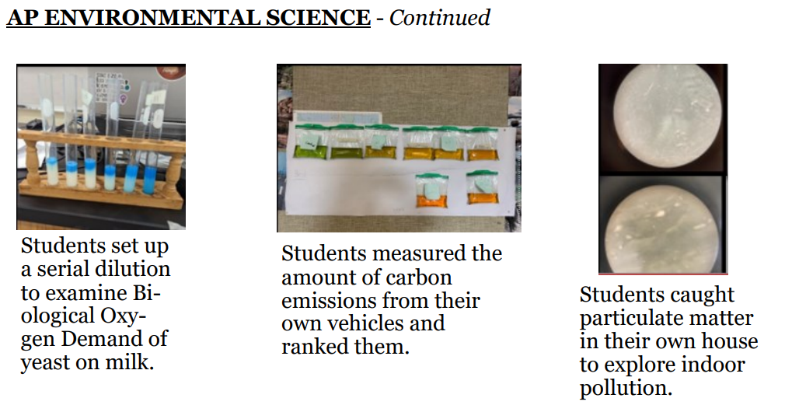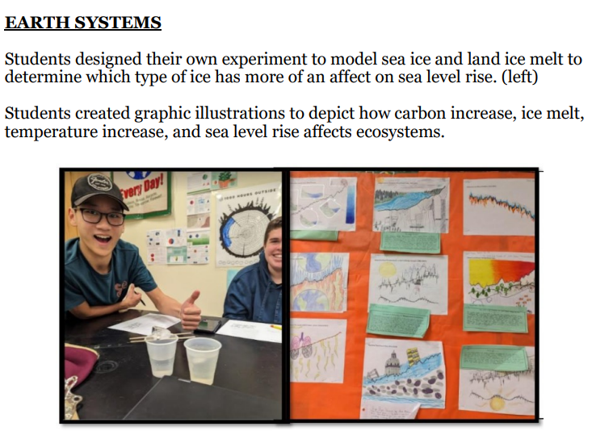
Student Sample 13
Student Sample 14

